**Medical Stock Interpretation –**

**Covid and the reclamation phase**

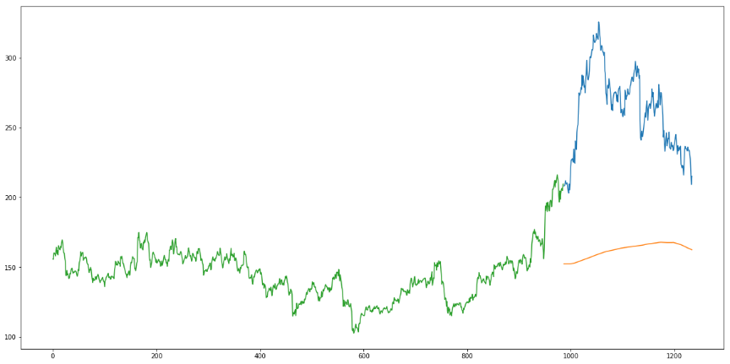

**Name:** Pavan kumar S(19BDS0073)

Hariharan R(19BDS0065)

**Course name:** Predictive Analytics

**Course code:** CSE 3502

**Course code:** CSE 3047

**Project review**:1

**Slot**: A2

**Introduction:**

Medical logistics is the logistics of surgical, medical, and pharmaceutical supplies. It also includes the supplies of medical devices, medical and laboratory equipment, and other items, products, and pieces of equipment to support dentists, doctors, veterinary physicians, nurses, and other healthcare providers. With the ever-increasing demand for medical logistics due to the surge in population, there exists always a need to get the goods, to be delivered on time with minimal cost and handle them with care to avoid any wastage. Faulty machines, expired medicines, and human negligence continue to be significantly contributing to medical errors which culminate in being the 3rd leading cause of death in the United States. With proper estimation of requirement, we can always expect the industry to fulfil the ever-rising demand. Surges in demand of medical equipment were observed during the pandemic especially with the case of oxygen concentrators and anti-viral pills. With the raise in demand of these goods the pharma industry stocks ran bull, as their equity reached all time high values. These patterns can reveal the expected demand for a similar scenario in future. The trends in the pharma sector stock values provide highly valuable information, as the pre-covid and post-covid analysis of these stocks reveal that the pharma sector have benefitted the most from the pandemic. Our research aims to use LSTM model (Long Short-Term Memory) to interpret meaningful information from the pharma industry stock data and compare it with the trends of the other sectors.

**Literature Review:**

1. **Systematic analysis and review of stock market prediction techniques:**

**Authors:** Dattatray P. Gandhmal, K. Kumar , **Year of publication:** 2019

**Abstract:**

Prediction of stock market trends is considered as an important task and is of great attention as predicting stock prices successfully may lead to attractive profits by making proper decisions. Stock market prediction is a major challenge owing to non-stationary, blaring, and chaotic data, and thus, the prediction becomes challenging among the investors to invest the money for making profits. Several techniques are devised in the existing techniques to predict the stock market trends. This work presents the detailed review of 50 research papers suggesting the methodologies, like Bayesian model, Fuzzy classifier, Artificial Neural Networks (ANN), Support Vector Machine (SVM) classifier, Neural Network (NN), Machine Learning Methods and so on, based on stock market prediction. The obtained papers are classified based on different prediction and clustering techniques. The research gaps and the challenges faced by the existing techniques are listed and elaborated, which help the researchers to upgrade the future works.

**(1) Analysis based on prediction techniques**

(a) ANN-based prediction techniques ANN captures the structural relationship between a stock’s performance and its determinant factors more accurately than many other statistical methods. In literature, various sets of input variables are utilized to predict stock returns. Some researchers pre-processed the input variables before applied it to the ANN for prediction.

(b) CNN based prediction techniques CNN is a feed-forward neural network. The number of hidden layers in a CNN is more than that in a conventional neural network. CNN is the renowned deep learning algorithms utilized to predict stock markets. The deep learning methods are utilized for determining and analyzing complicated patterns in the data and allow to speed up the trading process.

(c) DSS based prediction technique DSS can predict changes in stock prices, which are required by investors in the stock market. Wen, Q et al. developed an advanced intelligent trading system using oscillation box prediction by integrating the SVM algorithm with stock box theory. The box theory entails that a stock purchasing or retailing is successful if the price disrupts the original threshold value compared to other boxes. The trading mechanism using two bound forecasts is built for making effective decisions. The method failed to build advanced robust estimators for improving the accuracy of the forecasts by adopting additional soft computing methods.

(d) HMM-based prediction techniques Recently, HMM is applied to forecast and predict the stock market. HMM is successful in analyzing and predicting time depending phenomena, or time series. The different researches adopting the HMM based stock prediction are elucidated in this subsection. Badge, J., [47] developed various macro-economic factors for Indian stock market with different macro-economic factors, like technical indicators. These technical indicators are employed for deciding the patterns of the market in a specific time. The method failed to consider correlations for constructing the model. The performance is improved using the quantization by taking hour-by-hour and minute-by-minute stock values.

e) Naive Bayes based prediction technique Naïve Bayes algorithm is a classification method, which generates Bayesian Networks for a given dataset based on Bayes theorem. It presumes that the given dataset contains a particular feature in a class, which is unrelated to any other feature. Naïve Bayes algorithm is easy to build and useful for very large datasets and outperforms highly sophisticated classification techniques. The data is taken from the livestock market in real-time to analyze the stocks. Here, the deep LSTM based NN was designed using the embedded layer and the LSTM neural network using automatic encoder for predicting the stock trends. The embedded layer and automatic encoder were used for vectorizing the data using LSTM. However, the method was not applicable to the European and American stock market with large accuracy.

**Research gaps:**

The challenges faced by the NN based on stock market prediction are as follows: The devised ANN was not declared as an effective scheme for predicting the stock market as the neural models cannot tolerate high computational overhead due to large neurons contained in the hidden layer and appropriate weight adaption . NN, developed in , performed both the testing and the training at a slower rate; this affected the prediction performance. Moreover, overfitting, trapped in local minima and black box technique are the drawbacks which can be handled using NN. The obtained results of NN based stock market prediction system devised in were with low accuracy due to the influence of the misclassification of the analogous patterns and the network parameters utilized were not optimized. The research issue in the CNN based stock prediction method is that the devised CNN with the deep learning framework was not suitable for the highly extensive applications.

**Conclusion:**

The techniques utilized for the stock market prediction involves ANN, SVM, SVR, HMM, NN, fuzzy based techniques, K-means, and so on. In addition, the research gaps and the issues for predicting the stock market are elaborated for suggesting effective future scope. In addition, the research gaps and the issues for predicting the stock market are elaborated for suggesting effective future scope. The commonly used technique for attaining effective stock market prediction is ANN and the fuzzy-based technique.

**2)Applications of deep learning in stock market prediction: Recent progress**

**Author:** Weiwei Jiang ,**Year of publication:** 2021

**Abstract:**

Lately, deep learning models have been introduced as new frontiers for this topic and the rapid development is too fast to catch up. Hence, our motivation for this survey is to give a latest review of recent works on deep learning models for stock market prediction. We not only category the different data sources, various neural network structures, and common used evaluation metrics, but also the implementation and reproducibility. Our goal is to help the interested researchers to synchronize with the latest progress and also help them to easily reproduce the previous studies as baselines. Based on the summary, we also highlight some future research directions in this topic.

**Data preprocessing:**

Missing data imputation, denoising, feature extraction, dimensionality reduction, . Feature Normalization & Standardization, Data Split, Data Augmentation have been performed.

**Prediction Model:**

Feedforward neural network (FFNN). It is the simplest type of artificial neural network wherein connections between the nodes do not form a cycle. An artificial neural networks (ANN) are learning models inspired by biological neural networks, and the neuron in an ANN consists of an aggregation function which calculates the sum of the inputs, and an activation function which generates the outputs. An autoencoder (AE) is a subset of ANN which has the same number of nodes in the input and output layers. When ANN has two or more hidden layers, we denote it as deep neural network (DNN) is this survey. We also category the following models into this family because they share a similar structure: backpropagation neural network (BPNN), multilayer perceptron (MLP), extreme learning machines (ELM) where the parameters of hidden nodes need not be tuned, deep increasing–decreasing-linear neural network (IDLNN) where each layer is composed of a set of increasing–decreasing-linear processing units (de A. Araújo et al., 2019), stochastic time effective function neural network (STEFNN) (Wang & and Wang, 2015), radial basis function network (RBFN) that uses radial basis functions as activation functions.

• Convolutional neural network (CNN). Designed for processing two dimensional images, each group of neurons, which is also called a filter, performs a convolution operation to a different region of the input image and the neurons share the same weights, which reduces the number of parameters compared to the densely connected feedforward neural network. Pooling operations, e.g., max pooling, are used to reduce the original size and can be used for multiple times, until the final output is concatenated to a dense layer. Powered by the parallel processing ability of graphics processing unit (GPU), the training of CNN has been shortened and CNN has achieved an astonishing performance for image related tasks and competitions. By reducing the convolutional and pooling operations to a single temporal dimension, 1D CNN is proposed for time series classification and prediction, e.g., Deng et al. (2019) uses a 1-D fullyconvolutional network (FCN) architecture, where each hidden layer has the same length as the input layer, and zero padding is added to keep subsequent layers the same length as previous ones.

• Recurrent neural network (RNN). Compared with feedforward neural network, recurrent neural network is an artificial neural network wherein connections between the nodes form a cycle along a temporal sequence, which helps it to exhibit temporal dynamic behavior. However, normal RNNs are bothered by the vanishing gradient problem in practice, when the gradients of some of the weights start to shrink or enlarge if the network is unfolded too many times. Long short-term memory (LSTM) networks are RNNs that solve the vanishing gradient problem, where the hidden layer is replaced by recurrent gates called forget gates. Gated recurrent unit (GRU) is another RNN that uses forget gates, but has fewer parameters than LSTM. Bi-directional RNN are RNNs that connect two hidden layers of opposite directions to the same output. Both bi-directional LSTM (BiLSTM) and bi-directional GRU (BGRU) have been used for stock market prediction.

**Limitations:**

The limitations of this survey are summarized in three points. The first point is that only the recent progress of the deep learning application in the stock market is covered in this survey, without giving a whole picture of the relevant history. The second point is that the scope of this survey is limited to the stock market, without discussing the application of deep learning in other important financial markets, e.g., the foreign exchange and futures markets. The third point is that even though deep learning is proven as the state-of-the-art technique for predicting the stock market in most of the surveyed studies, this survey does not aim to provide a comprehensive experimental comparison between deep learning and other prediction techniques, which requires a huge amount of computation resource and is left for future studies.

**3)Economic impact of COVID-19 pandemic on healthcare facilities and systems: International perspectives**

**Authors:** Alan D.KayeMD, PhD(Provost & Vice Chancellor of Academic Affairs)aChikezie N.OkeaguMD(Assistant Professor)bAlex D.PhamMD(Resident Physician)cRayce A.Silva(Medical Student)dJoshua J.HurleyMD, PGY-1(Resident Physician)eBrett L.ArronMD(Associate Professor)fNoeenSarfrazMD MPH(Resident Physician)gHong N.LeeMD(Assistant Professor)hG.E.GhaliDDS, MD, FACS, FRCS(Ed)(Chancellor)iJack W.Gamble(Professor and Chairman)iHenryLiuMD(Professor)jRichard D.UrmanMD(Associate Professor)kElyse M.CornettPhD(Assistant Professor)

**Introduction:**

International hospitals and healthcare facilities are facing catastrophic financial challenges related to the COVID-19 pandemic. The American Hospital Association estimates a financial impact of $202.6 billion in lost revenue for America's hospitals and healthcare systems, or an average of $50.7 billion per month. Furthermore, it could cost low- and middle-income countries ~ US$52 billion (equivalent to US$8.60 per person) each four weeks to provide an effective healthcare response to COVID-19. In the setting of the largest daily COVID-19 new cases in the US, this burden will influence patient care, surgeries, and surgical outcomes.

**Effective risk reduction strategies**

Effective risk reduction strategies to prevent airborne and contact transmission of the novel corona virus SARS-CoV-2 requires a system safety approach factoring in viral sensitivities, strategies for environmental bioburden reduction, disinfection practices, ventilation controls, and human factors.Pre-symptomatic and symptomatic individuals prolifically shed the virus in diverse arrays of droplets and aerosols. The first step in reducing COVID-19 transmission risk is minimizing infective bioburden release into work, break, and lavatory environs. This is accomplished first by keeping ill and potentially infected person at home to the extent possible. Wearing masks consistently reduces the volume and degree of projected release of infectious viral-laden bioburden, providing significant risk reduction to the wearers' co-workers. Intact skin provides protection from viral penetration but not from transfer to mucous membranes. Thorough handwashing with soap and water at the start of the day reduces the infective bioburden transported in from the outside from contact with contaminated surfaces and suspended droplets and aerosols. Workplace surfaces, including drawer handles and doorknobs/bars, should be wiped down with high disinfectants at regular intervals depending on the frequency of use and number of staff sharing the equipment. Break rooms used by staff for coffee breaks and meals and bathrooms present unique challenges. Lower air volume exchange rates allow aerosols to persist longer. Masks are removed during meals. This facilitates increased release and transmission of infective droplets and aerosols from contagious individual(s). Best work practices include wearing high-quality masks, social distancing as much as possible, surveillance testing based on community positivity rates, contact tracing, and post-exposure isolation until antigen tests are negative after a reasonable post-exposure interval and well-considered cleaning paradigms should be the norm.

**Conclusion**

As the COVID-19 pandemic continues to spread through many parts of the world, it is leaving in its wake a devastating trail of destruction. Aside from the rising number of cases and deaths, a consequence that is reasonably expected, the virus has had an insidious effect on economies around the world. Following the declaration of COVID-19 as a pandemic in March 2020, global commerce came to a virtual halt as restrictions were imposed on travel, and people around the world took heed of social distancing guidelines that encouraged them to stay in their homes as much as possible. China was the original epicentre of the pandemic after the first cases were reported in Wuhan. From there, the virus spread to many countries including the United States, India, Brazil, Singapore, and disproportionately affected low- and middle-income countries and individuals. A lack of preparedness was a major contributor to the struggles experienced by healthcare facilities around the world. Alternative strategies such as telemedicine, social distancing, mask-wearing, handwashing, and quarantining have all helped decrease the effects of the COVID-19 pandemic and will likely influence healthcare for the foreseeable future.

**4)Stock closing price prediction based on sentiment analysis and LSTM:**

**Authors:** Zhigang Jin1 • Yang Yang1 • Yuhong Liu2, **Year of publication:** 2019

**Abstract:**

The timely prediction of the market is generally regarded as one of the most challenging problems due to the stock market’s characteristics of noise and volatility. To address these challenges, we propose a deep learning-based stock market prediction model that considers investors’ emotional tendency. First, we propose to involve investors’ sentiment for stock prediction, which can effectively improve the model prediction accuracy. Second, the stock pricing sequence is a complex time sequence with different scales of fluctuations, making the accurate prediction very challenging. We propose to gradually decompose the complex sequence of stock price by adopting empirical modal decomposition (EMD), which yields better prediction accuracy. Third, we adopt LSTM due to its advantages of analyzing relationships among timeseries data through its memory function. We further revised it by adopting attention mechanism to focus more on the more critical information. Experiment results show that the revised LSTM model can not only improve prediction accuracy, but also reduce time delay. It is confirmed that investors’ emotional tendency is effective to improve the predicted results; the introduction of EMD can improve the predictability of inventory sequences; and the attention mechanism can help LSTM to efficiently extract specific information and current mission objectives from the information ocean.

**The Proposed S_EMDAM_LSTM model:**

Different from base model of CNN, we integrate it with word2vec by changing initialization of word vector. Word2vec is a model to learn semantic knowledge from a large amount of text in an unsupervised way. The key of word2vec is to map words from the original space to the new multidimensional space. In this project, word2vec is introduced to first train large-scale stock comment corpora and learn high-dimensional vector representations of phrases. Then, the word vector representation of the stock comments to be classified is calculated by word2vec. If the phrase in the stock comments to be classified exists in the trained large-scale stock comments corpus, the result is directly used. Otherwise, it is randomly initialized by word2vec. Then, the word vectors, which represent the preprocessed text, will be provided as the input for CNN. After that, based on the CNN model improved by word2vec, we calculate the sentiment index for sentiment analysis of the group.

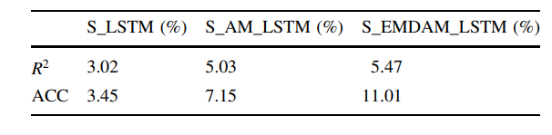

**Conclusion:**

According to experiments conducted on the dataset of AAPL, the performance of the proposed scheme has been verified. The experimental results show that the proposed scheme outperforms the comparison schemes consistently in three main aspects, including closer predicted closing price, higher rise and fall classification accuracy and lower time offset.

**5) A Data-driven Auto-CNN-LSTM Prediction Model for Lithium-ion Battery Remaining Useful Life:**

**Authors:** Lei Ren, Jiabao Dong, Xiaokang Wang, Zihao Meng, Li Zhao, and M. Jamal Deen ,

**Year of publication:** 2020

**Abstract:**

Due to insufficient amount of degradation data, the prediction accuracy of data-driven methods is greatly limited. Besides, mathematical models established by model-driven methods to represent degradation process are unstable because of external factors like temperature. To solve this problem, a new Lithium-ion battery RUL prediction method, namely Auto-CNNLSTM, is proposed in this work. This method is developed based on deep convolution neural network (CNN) and long short-term memory (LSTM) to mine deeper information in finite data. In this method, a autoencoder is utilized to augment the dimensions of data for more effective training of CNN and LSTM.

**Methodology:**

Due to ability of CNN to mine hidden information in limited data, and the ability of LSTM to process information in time series, we propose a lithium-ion battery RUL prediction method based on CNN and LSTM. Moreover, the convolution layers of CNN require much data but the data of LIB are insufficient. However, by using a autoencoder, we achieved a significant increase in the dimensions of data that can be transmitted to the CNN for more effective training. Also, considering the noise presented in the model prediction curve, we propose a post-smoothing method to reduce noise and solve the discontinuity problem in the prediction results. This improves the interpretability of the prediction results by outputting smooth prediction curve.

**Analysis of Results:**

From the experimental results, the RUL prediction results are satisfactory. The RMSE is 5.03%, and the accuracy is 94.97%. The reason for the error may be that the amount of data is still insufficient even though the original data is augmented with the autoencoder. The RUL prediction curves are well fitted, but the curve at 60th to 100th generation for #7 LIB (15th to 20th for #28 LIB) on the abscissa is still rough. Therefore, this paper adopts the idea of filtering and performs first-order linear, second-order and third-order filtering respectively.

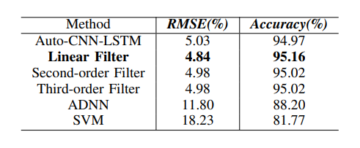

**Objective of the research:**

To analyze the trends of the pharma industry and interpret useful information out of it. The research also focusses on identifying patterns to understand the demands, and with this knowledge we expect the industries to be prepared to address a demand of similar kind in future.

**6)COVID-19, extractive industries, and indigenous communities in Canada: Notes towards a political economy research agenda**

**Abstract:**

The economic changes have already affected industry-Indigenous relations in Canada in several important and interesting ways. Extractive industries were associated with the dispossession of Indigenous lands and resources. That said, it would be a mistake to assume that Indigenous communities are inherently opposed to resource extraction . Some Indigenous communities have embraced extractive industries as a driver of community development and as a means of furthering goals of self-determination. Many others, stuck with extractive projects on their territories that proceeded either with or without their consent, seek to pragmatically make the most of the situations they find themselves in . In both cases, Indigenous communities become stuck in the often-unfavorable position of trying to maximize local benefits and minimize negative effects.

**Interpretations:**

First and foremost, conflicts over the implications of extractive industries for community health have already intensified significantly.

During normal operations of mining and energy projects community health is often a concern for Indigenous communities.A second point of struggle that is likely to intensify is environmental protection. Under normal circumstances, there tends to be conflicts

between Indigenous communities and extractive industries over the appropriate measures to protect the local environment. Along with conflicts over environmental protection, we are likely tosee increased conflict over the economic benefits Indigenous communities capture as a result of extraction on their territories, which is the third point of struggle we identify.

**Conclusion:**

Their discussion of how the COVID pandemic would affect political struggles over the benefits and impacts of extraction was decidedly bleak, as they anticipated that industry would increasingly demand Indigenous communities sacrifice their health, environment, aspirations for economic development, and political rights. That said, there were reasons to be optimistic, especially the many examples of determined resistance from Indigenous communities. In any case, it was important for scholars to track how these conflicts develop to help Indigenous communities produce strategies to respond to the changing political dynamics they identified in their paper.

**Methodology:**

**Paper organization (That we propose to write):**

1)Abstract

An abstract is a short summary of our completed research. It is intended to describe our work without going into detail. Our abstracts are designed to be self-contained and concise, explaining our work as briefly and clearly as possible.

1. Introduction

The introduction to our research paper presents our topic, provides background, and details of our research problem. It also explains how the proposed solution is expected to address the existing problem.

3)Dataset description

An usual dataset description contains the details of the equipment used, such as the make and model of the instrument, the settings used, information on how it was calibrated. the text of survey instruments used, including questionnaires and interview templates. In our case it illustrates the sources from which the data was collected, the preprocessing that was done and the visualisation done in a hypothetical stage.

4)Methodology

Our methodology section allows the reader to critically evaluate our study's overall validity and reliability. It includes the technical models, the coding principles and steps to be taken to simulate our research.

5)Conclusion

Our conclusion summarizes the overall arguments of our findings.

**Basic concepts:**

The stock market indices (NIFTY and SENSEX) indicate the country’s wealth and the strength of the economy. The crash of the stock market indicates that there is a economical/political crisis prevalent in the country during that span of time. History has been repeating itself with repeated crashes once in a decade. In the year 2008 the world witnessed a crash with the crisis starting at Wall Street, which lead to the impact being experienced for several years. A simple analysis of the stock data taken during those periods would easily reveal that there must be an anomaly, which lead to the sudden dip in values.

So using the same strategy to find out the underlying fact about the covid impact on economy, and how medical trends have been varying, we plan to use the data from 2019 to 2021, i.e pre-covid and the recovery phase of covid.

**Overview of the proposed model:**

**3.1. Highlight the need for indeterminacy**

Since the crash of stock market and economy downfall is prone to occur atleast once every decade, it is important to analyse how the economy have performed, how long it took to recover from the disaster and what industries have helped ease the situation. The identification of the recovery planning done during these disasters would prove handy to address similar economic crashes in the future.

**3.2. Dataset Description**

The dataset is expected to contain 7 columns and around 1500 rows with the date, open, high and volume being the most significant attributes. The dataset is built by the authors after formatting through Microsoft Excel and RStudio. The source provider of the stock data was yahoo finance, whose historical data section provided us the desired data. Investing.com also provided us the data that weren’t available with the former. The data was readily available through csv format, but due to the difference in source providers it required a little formatting, which was done using RStudio (in r programming language).It is important to understand the design of our dataset, the way the trend varies before proceeding to carry out other operations. So the visualization depicted below shows the distribution of time vs adj.close values.

The link to the provisional dataset is given below. The dataset has been termed provisional as the research is at the initial stage and depending on the results obtained we may add more rows/columns to the dataset to obtain a more clearer results.

CIPLA

DR.REDDY

PHARMA NIFTY

**Model description:**

Long Short-Term Memory (LSTM) networks are a type of recurrent neural network capable of learning order dependence in sequence prediction problems. Time is a very important factor in stock market, as the golden rule of stock market tells that “History repeats itself”, so with careful analysis on time, supported by huge volumes of data, one can be able to interpret the price of the stock in future and identify the reason behind the format of patterns.

The more time passes, the less likely it becomes that the next output depends on a very old input. This time dependency distance itself is as well as contextual information to be learned. LSTM networks manage this by learning when to remember and when to forget.

LSTM has three gates:

* The input gate: The input gate adds information to the cell state,
* The forget gate: It removes the information that is no longer required by the model,
* The output gate: Output Gate at LSTM selects the information to be shown as output.

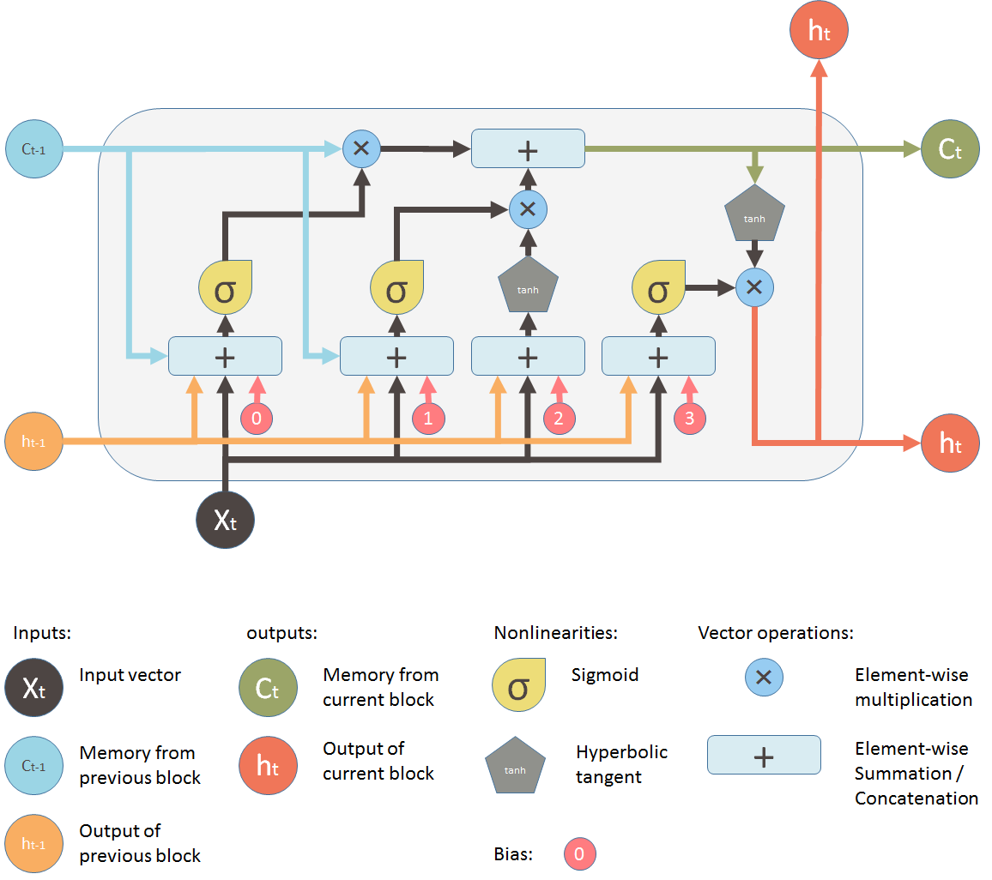

*COURTESY:MEDIUM*

***Why LSTM for stock data interpretation?***

*Long short term memory (LSTM) is a model that increases the memory of recurrent neural networks. Recurrent neural networks hold short term memory in that they allow earlier determining information to be employed in the current neural networks. For immediate tasks, the earlier data is used. We may not possess a list of all of the earlier information for the neural node. In RNNs, LSTMs are very widely used in Neural networks. Their effectiveness should be implemented to multiple sequence modelling problems in many application domains like video, NLP, geospatial, and time-series.*

*The code used for the preprocessing has been shown below:*

#import the necessary libraries

library(dplyr)

library(base)

install.packages("stringr")

library(stringr)

library(graphics)

install.packages("ggplot2")

library(ggplot2)

#Read the dataset

df<-read.csv('historical data nifty_pharma.csv')

View(df)

#Rename the columns to more meaningful names. This is always a good practice.

names(df)[1] <- "Date"

names(df)[6]<-"Volume"

names(df)

#Select only necessary columns and remove unwanted columns

new_df<-df[1:6]

View(new_df)

#Format the dates to a more standard format

date <- as.Date(new_df$Date,format = "%B %d,%Y")

typeof(date)

date<-strftime(date,"%d-%m-%Y")

new_df$Date<-date

View(new_df)

#As data were obtained from different sources , it is important to standardise them to a same format. So in one data source , “M” was used to represent million. So we change that to numerical value

volume<-gsub("M","000",new_df$Volume)

volume<-gsub("\\.","",volume)

new_df$Volume<-volume

View(new_df)

names(new_df)[2]<-"Adj Close"

View(new_df)

#Reorder the columns

df <- new_df[, c(1,3, 4, 5, 2,6)]

View(df)

write.csv(df,"nifty_data.csv", row.names = FALSE)

#Visualising the data to gain hypothetical understanding.

data1<-read.csv('CIPLA.NS.csv')

View(data1)

data1<-data1[data1$Stock.Name=="CIPLA",1:6]

data2<-read.csv('CIPLA.NS.csv')

View(data2)

data2<-data2[data2$Stock.Name=="DR.REDDY",1:6]

data3<-read.csv('CIPLA.NS.csv')

View(data3)

data3<-data3[data3$Stock.Name=="PHARMA NIFTY",1:6]

data3 %>%tail(10) %>%ggplot(aes(x=Date, y=Adj.Close, group = 1)) +

  geom_line() +

  geom_point()

**Comparison and Discussion:**

The LSTM has been a very common model used to estimate the stock’s price. The reason they work so well is that LSTM can store past important information and forget the information that is not.

**Results:**

The research is at a very primitive stage to conclude on a valid result. For the time being, it was clearly observed that there was some sudden spikes in the recovery phase, mainly due to introduction of covid vaccines or any antiviral pills. The CIPLA and DR.REDDY being two leading players in the pharma industry have ran strong bullish runs during the entire pandemic period, as the all time high values of these stocks increased more than 200% from their pre-pandemic values. Further analysis of the pharma stocks during the course of study indicate that similar patterns were observed in other countries, say for example in the U.S, Pfizer stock’s soared up , when they launched the Pfizer-BioNTech COVID-19 Vaccine.

**Bibliographical styles:**

**1)** Dattatray P. Gandhmal, K. Kumar,Systematic analysis and review of stock market prediction techniques,Computer Science Review,Volume 34,2019, 100190,ISSN 1574-0137, https://doi.org/10.1016/j.cosrev.2019.08.001.

(https://www.sciencedirect.com/science/article/pii/S157401371930084X) 2)

**2)** Weiwei Jiang,Applications of deep learning in stock market prediction: Recent progress,Expert Systems with Applications,Volume 184,2021,115537,ISSN 09574174,https://doi.org/10.1016/j.eswa.2021.115537.

(<https://www.sciencedirect.com/science/article/pii/S0957417421009441>)

**3)** Alan D. Kaye, Chikezie N. Okeagu, Alex D. Pham, Rayce A. Silva, Joshua J. Hurley, Brett L. Arron, Noeen Sarfraz, Hong N. Lee, G.E. Ghali, Jack W. Gamble, Henry Liu, Richard D. Urman, Elyse M. Cornett,Economic impact of COVID-19 pandemic on healthcare facilities and systems: International perspectives,Best Practice & Research Clinical Anaesthesiology,Volume 35, Issue 3,2021,Pages 293-306,ISSN 1521-6896, https://doi.org/10.1016/j.bpa.2020.11.009.

(<https://www.sciencedirect.com/science/article/pii/S1521689620301142>)

**4)** Jin, Z., Yang, Y. & Liu, Y. Stock closing price prediction based on sentiment analysis and LSTM. Neural Comput & Applic 32, 9713–9729 (2020). https://doi.org/10.1007/s00521-019-04504-2

(<https://link.springer.com/article/10.1007/s00521-019-04504-2#citeas>)

**5)** L. Ren, J. Dong, X. Wang, Z. Meng, L. Zhao and M. J. Deen, "A Data-Driven Auto-CNN-LSTM Prediction Model for Lithium-Ion Battery Remaining Useful Life," in IEEE Transactions on Industrial Informatics, vol. 17, no. 5, pp. 3478-3487, May 2021, doi: 10.1109/TII.2020.3008223.

(<https://ieeexplore.ieee.org/abstract/document/9137406>)

**6)** Warren Bernauer, Gabrielle Slowey,

COVID-19, extractive industries, and indigenous communities in Canada: Notes towards a political economy research agenda, The Extractive Industries and Society,Volume 7, Issue 3,2020,Pages 844-846,ISSN 2214-790X,

https://doi.org/10.1016/j.exis.2020.05.012.

(<https://www.sciencedirect.com/science/article/pii/S2214790X20301544>)